# Learning Outcome

# After completing this module, the student should be able to understand JavaScript

To meet the learning outcome, a student has to complete the following activities

1. Create the following four functions in a separate JavaScript file. Also create a separate HTML file to test the functions.
   1. Create a function that uses an alert to display the hostname of the current URL when the button is clicked.
   2. Create a function to display a confirmation box with the message "Are you human?", and output what the user clicked
   3. Display a prompt box which asks the user for her/his name, store the user’s response in person, and output a message; "Hello " + person + "! How are you today?
   4. Use the switch statement together with prompt () to execute a block of code based on user input. Click the button to display a dialog box which will ask for the user’s favourite drink. (3 Hrs)
2. Write a JavaScript function to remove specified number of characters from a string.

(1 Hr)

1. Develop and demonstrate a HTML5 file that includes JavaScript script that uses functions for the following problems:

a. Parameter: A string

Output: The position in the string of the left-most vowel

b. Parameter: A number

Output: The number with its digits in the reverse order (2 Hrs)

1. Write a JavaScript code that displays text “TEXT-GROWING” with increasing font size in the interval of 100ms in RED COLOR, when the font size reaches 50pt it displays “TEXT-SHRINKING” in BLUE color. Then the font size decreases to 5pt. (3 Hrs)
2. Create a Tip Calculator as a single page web application (SPA). Design an interface that allows you to enter the amount of the tip. The percentage you would like to tip, and the number of people to split the tip with. Do not use 3 text input elements! Calculate and dynamically display the tip. (3 Hrs)
3. Write a JavaScript function to validate whether a given value is object or not. (1 Hr)
4. Write a JavaScript function to validate whether a given value type is pure json object or not. (1 Hr)
5. Write a JavaScript program to count number of words in string.

Note :

Remove white-space from start and end position.

Convert 2 or more spaces to 1.

Exclude newline with a start spacing. (3 Hrs)

1. Write a JavaScript function to check a given value contains alpha, dash and underscore.

(1 Hr)

1. Write a JavaScript function to check whether a given value represents a domain or not.

Write a JavaScript function to check whether a given value is html or not. (1 Hr)

# Activity 12

## Aim: Create the following four functions in a separate JavaScript file. Also create a separate HTML file to test the functions.

## Create a function that uses an alert to display the hostname of the current URL when the button is clicked.

## Create a function to display a confirmation box with the message "Are you human?", and output what the user clicked

## Display a prompt box which asks the user for her/his name, store the user’s response in person, and output a message; "Hello " + person + "! How are you today?

## Use the switch statement together with prompt () to execute a block of code based on user input. Click the button to display a dialog box which will ask for the user’s favourite drink.

**Learning outcome:** Able to understand JavaScript

**Duration:** 3 Hours

**List of Hardware/Software requirements:**

1. Windows/Ubuntu OS
2. Text Editors- Notepad++, VS Code, Sublime Text, etc.
3. Web Browser (Chrome/Firefox)

**Program:**

<!DOCTYPE html>

<html lang="en">

<head> <! -- Document Head Starts -->

<meta charset="UTF-8">

<meta http-equiv="X-UA-Compatible" content="IE=edge">

<meta name="viewport" content="width=device-width, initial-scale=1.0">

<title>JS_Alert</title>

</head> <! -- Document Head Ends -->

<body> <! -- Document Body Starts -->

<h1>The Window Object</h1>

<h2>The alert() Method</h2>

<p>Click the button to alert the hostname of the current URL.</p> <!--Paragraph Element-->

<button id="inp" style="color:red;font-weight: bold;border:2px solid blue;">Location</button>

<script> //Javascript Starts

function disp() {

window.alert(location.hostname);

window.alert(location.pathname));

}

let button=document.getElementById("inp");

button.onclick=disp;

</script> //Javascript Ends

</body> <! -- Document Body Ends -->

</html>

**Output:**

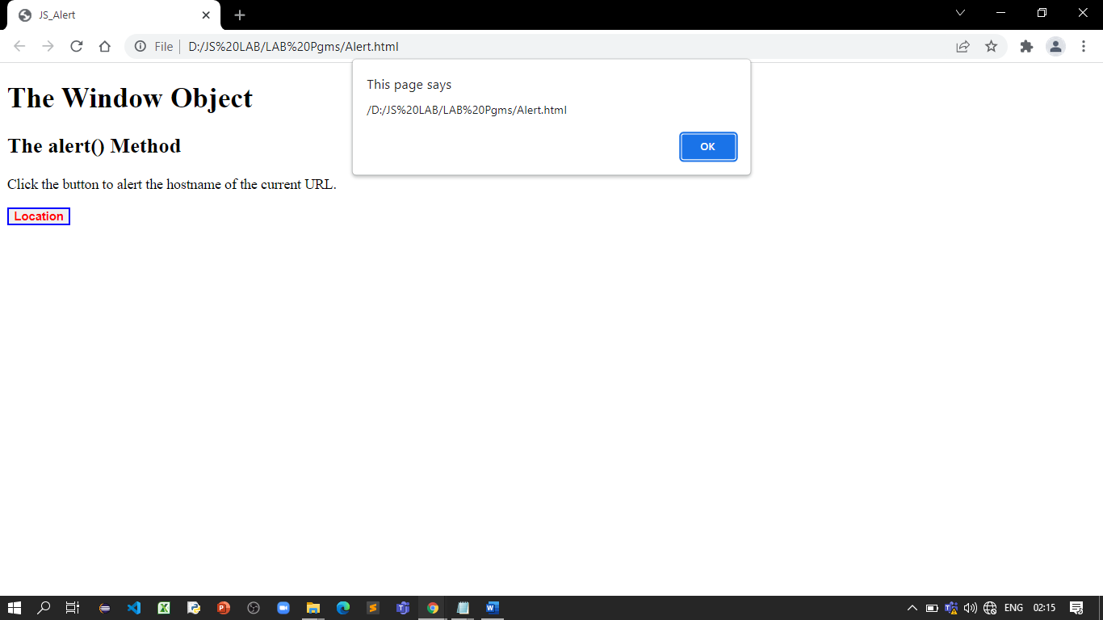

**Program:**

<!DOCTYPE html>

<html lang="en">

<head> <! -- Document Head Starts -->

<meta charset="UTF-8">

<meta http-equiv="X-UA-Compatible" content="IE=edge">

<meta name="viewport" content="width=device-width, initial-scale=1.0">

<title>JS_Confirm</title>

</head> <! -- Document Head Ends -->

<body> <! -- Document Body Starts -->

<h1>The Window Object</h1>

<h2>The confirm() Method</h2>

<p>Click the button to display a confirm box</p> > <!--Paragraph Element-->

<button id="inp" style="color:red;font-weight: bold;border:2px solid blue;">Confirm</button>

<p id="demo" style="background-color:yellow;color:red;display:inline;"></p>

<script> //Javascript Starts

function result()

{

let text;

if (confirm("Press a button!") == true) {

text = "Are you Human?";

} else

{

text = "You canceled!";

}

document.getElementById("demo").innerHTML = text;

}

let button=document.getElementById("inp");

button.onclick=result;

</script> //Javascript Ends

</body> <! -- Document Body Ends -->

</html>

**Output:**

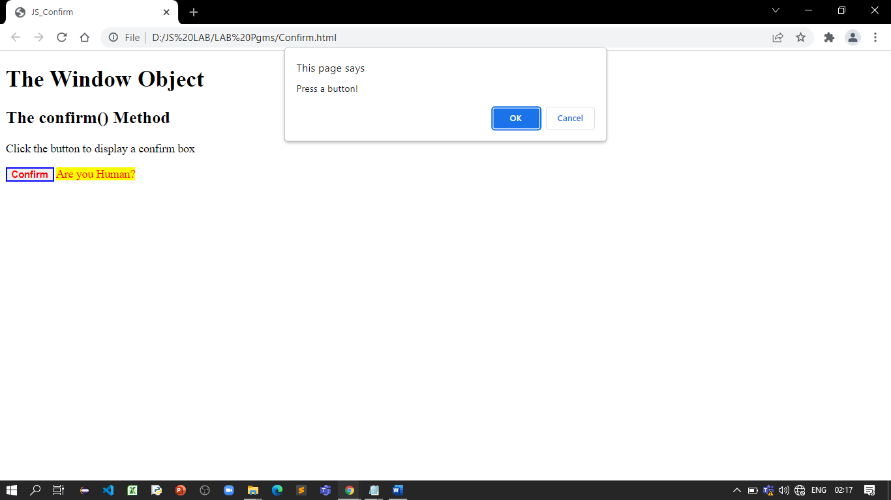

**Program:**

<!DOCTYPE html>

<html lang="en">

<head> <! -- Document Head Starts -->

<meta charset="UTF-8">

<meta http-equiv="X-UA-Compatible" content="IE=edge">

<meta name="viewport" content="width=device-width, initial-scale=1.0">

<title>JS_Prompt</title>

</head> <! -- Document Head Ends -->

<body> <! -- Document Body Starts -->

<h1>The Window Object</h1>

<h2>The prompt() Method</h2>

<p>Click the button to demonstrate the prompt box.</p>> <!--Paragraph Element-->

<button id="inp" style="color:red;font-weight: bold;border:2px solid blue;">Click</button>

<p id="demo" style="background-color:yellow;color:red;display:inline;"></p>

<script> //Javascript Starts

function dispname()

{

let person = prompt("Please enter your name", "Harry");

if (person != null) {

document.getElementById("demo").innerHTML ="Hello " + person + "! How are you today?";

}

}

let button=document.getElementById("inp");

button.onclick=dispname;

</script> //Javascript Ends

</body> <! -- Document Body Ends -->

</html>

**Output:**

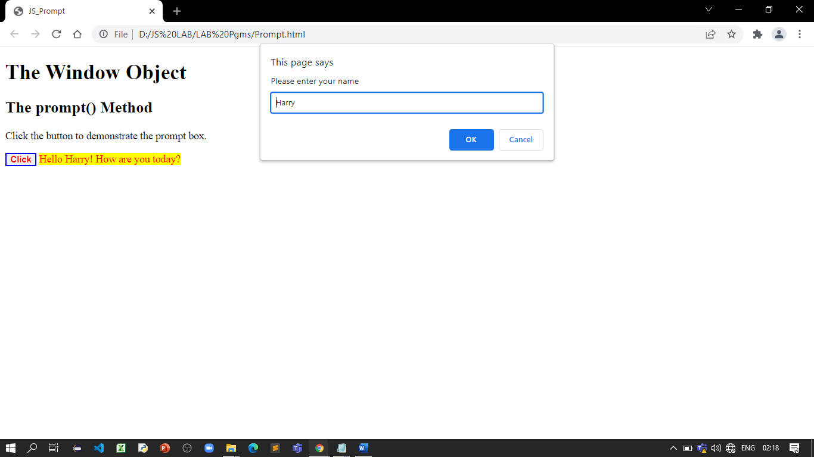

**Program:**

<!DOCTYPE html>

<html lang="en">

<head> <! -- Document Head Starts -->

<meta charset="UTF-8">

<meta http-equiv="X-UA-Compatible" content="IE=edge">

<meta name="viewport" content="width=device-width, initial-scale=1.0">

<title>JS_SwitchPrompt</title>

</head> <! -- Document Head Ends -->

<body> <! -- Document Body Starts -->

<h1>The Window Object</h1>

<h2>The prompt() Method</h2>

<p>Click the button to ask for your favorite drink</p>> <!--Paragraph Element-->

<button id="inp" style="color:red;font-weight: bold;border:2px solid blue;">Fav Drink</button>

<p id="demo" style="background-color:yellow;color:red;display:inline;"></p>

<script> //JavaScript Starts

function favdrink()

{

let text;

let favDrink = prompt("What's your favorite drink?", "Coca-Cola");

switch(favDrink) {

case "Coca-Cola":

text = "Excellent choice. Coca-Cola is good for your soul.";

break;

case "7up":

text = "7up is my favorite too!";

break;

case "Sprite":

text = "Really? Are you sure the Sprite is your favorite?";

break;

default:

text = "I have never heard of that one..";

}

document.getElementById("demo").innerHTML = text;

}

let button=document.getElementById("inp");

button.onclick=favdrink;

</script> //Javascript Ends

</body> <! -- Document Body Ends -->

</html>

**Output:**

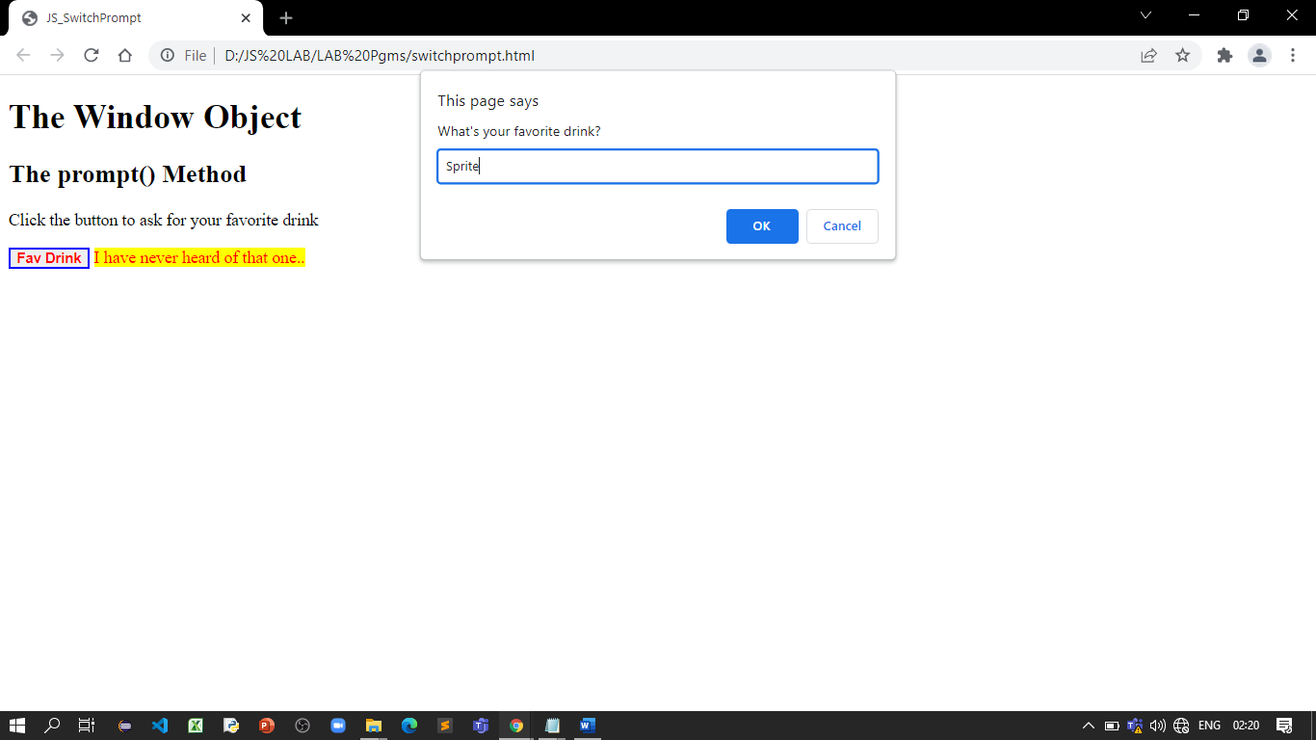

**References:**

* <https://www.w3schools.com/jsref/met_win_alert.asp>
* <https://www.w3schools.com/jsref/met_win_prompt.asp>

# Activity 13

## Aim: Write a JavaScript function to remove specified number of characters from a string.

**Learning outcome:** Able to understand JavaScript

**Duration:** 1 Hour

**List of Hardware/Software requirements:**

1. Windows/Ubuntu OS
2. Text Editors- Notepad++, VS Code, Sublime Text, etc.
3. Web Browser (Chrome/Firefox)

**Program:**

<!DOCTYPE html>

<html lang="en">

<head> <! -- Document Head Starts -->

<meta charset="UTF-8">

<meta http-equiv="X-UA-Compatible" content="IE=edge">

<meta name="viewport" content="width=device-width, initial-scale=1.0">

<title>Remove Characters</title>

</head> <! -- Document Head Ends -->

<body> <! -- Document Body Starts -->

<p>JavaScript function to remove specified number of characters from a string</p>>

<!--Paragraph Element-->

<script> //Javascript Starts

truncate_string = function (str1, length) {

if ((str1.constructor === String) && (length>0)) {

return str1.slice(0, length);

}

};

var nofcar=4;

document.write(truncate_string("Programming",nofcar));

</script> //Javascript Ends

</body> <! -- Document Body Ends -->

</html>

**Output:**

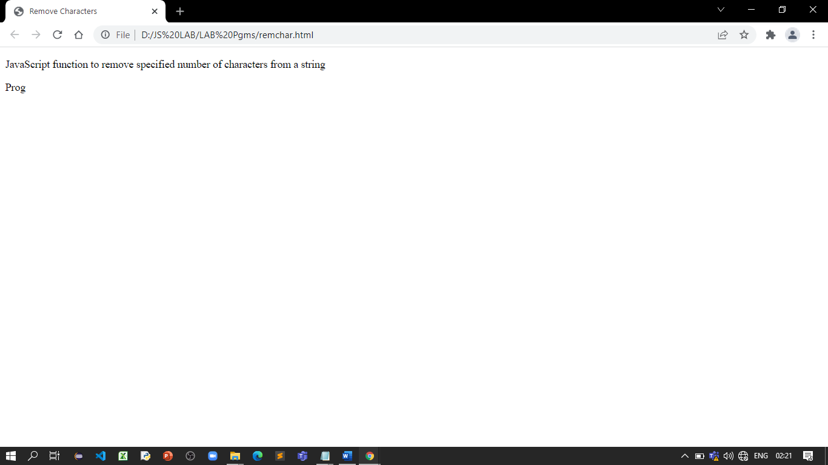

**References:**

* <https://www.w3resource.com/javascript-exercises/javascript-string-exercise-4.php>

# Activity 14

## Aim: Develop and demonstrate a HTML5 file that includes JavaScript script that uses functions for the following problems:

## Parameter: A string

## Output: The position in the string of the left-most vowel

## Parameter: A number

## Output: The number with its digits in the reverse order

**Learning outcome:** Able to understand JavaScript

**Duration:** 2 Hours

**List of Hardware/Software requirements:**

1. Windows/Ubuntu OS
2. Text Editors- Notepad++, VS Code, Sublime Text, etc.
3. Web Browser (Chrome/Firefox)

**Program:**

<!DOCTYPE html>

<html lang="en">

<head> <! -- Document Head Starts -->

<meta charset="UTF-8">

<meta http-equiv="X-UA-Compatible" content="IE=edge">

<meta name="viewport" content="width=device-width, initial-scale=1.0">

<title>Demons-Number & String</title>

</head> <! -- Document Head Ends -->

<body> <! -- Document Body Starts -->

<p style="color:blue;">Develop and demonstrate a HTML5 file that includes JavaScript script that uses functions for the following problems:

a. Parameter: A string

Output: The position in the string of the left-most vowel

b. Parameter: A number

</p>

<script> //Javascript Starts

var str = prompt("Enter the Input","");

if(!(isNaN(str)))

{

var num,rev=0,remainder;

num = parseInt(str);

while(num!=0) {

remainder = num%10;

num = parseInt(num/10);

rev = rev * 10 + remainder;

}

alert("Reverse of "+str+" is "+rev);

}

else

{

for(var i = 0; i<str.length; i++)

{

if (str.charAt(i) =='a' || str.charAt(i) == 'e' || str.charAt(i) =='i'

|| str.charAt(i) == 'o' || str.charAt(i) == 'u' || str.charAt(i) == 'A' ||

str.charAt(i) == 'E' || str.charAt(i) =='I' || str.charAt(i) =='O' || str.charAt(i) == 'U')

{

document.write("The entered string is:" +str+ "<br/>");

document.write("The leftmost vowel is :"+str.charAt(i)+"<br/>");

var pos = i+1;

document.write("The position of the leftmost vowel " +str.charAt(i)+ " is:" +pos+"\n");

exit;

}

}

document.write("The entered string is:" + str + "<br/>");

document.write("The entered string has no vowels");

}

</script> //Javascript Ends

</body> <! -- Document Body Ends -->

</html>

**Output:**

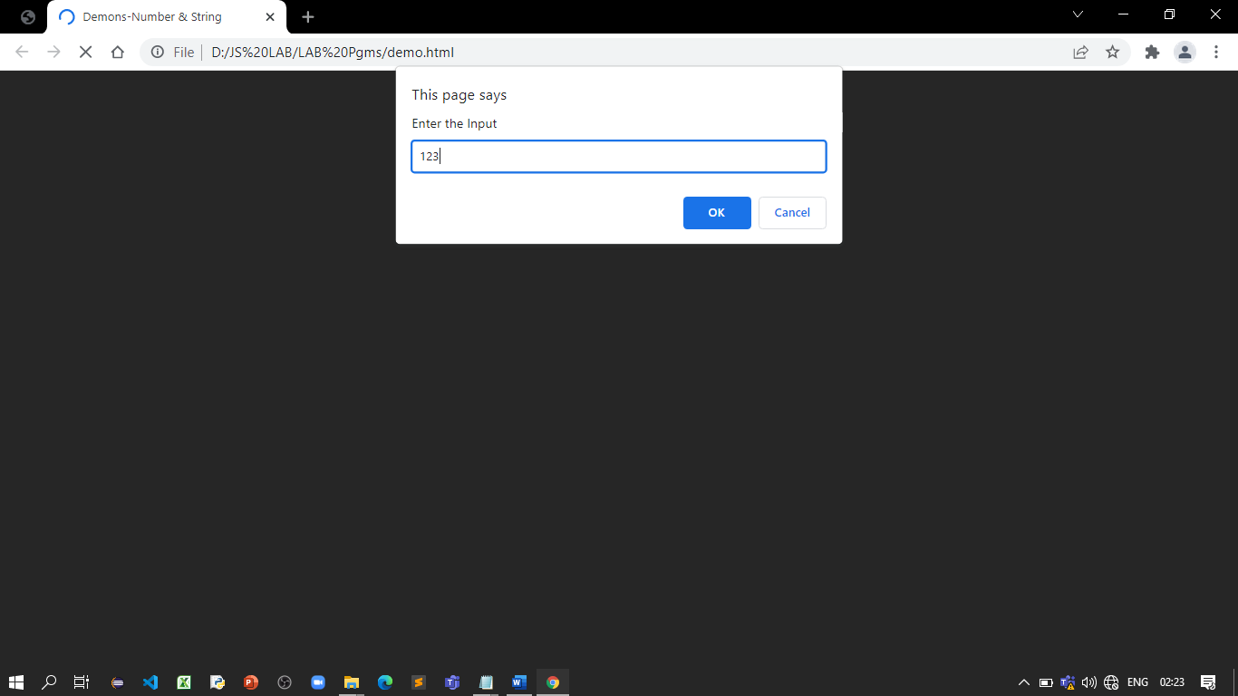

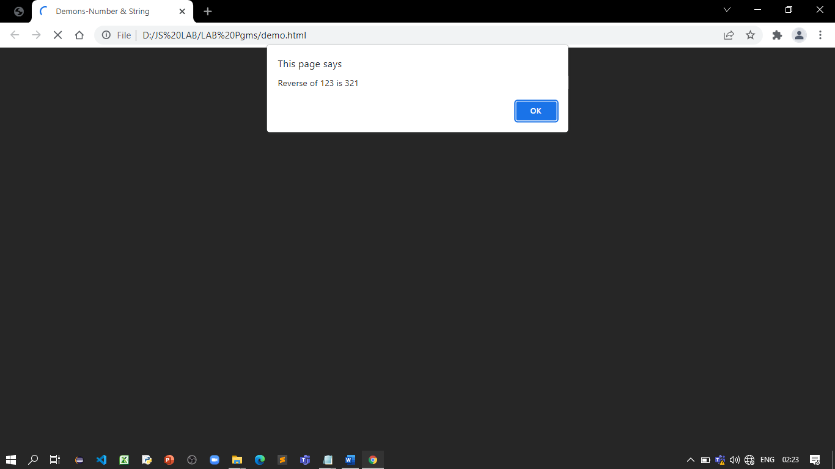

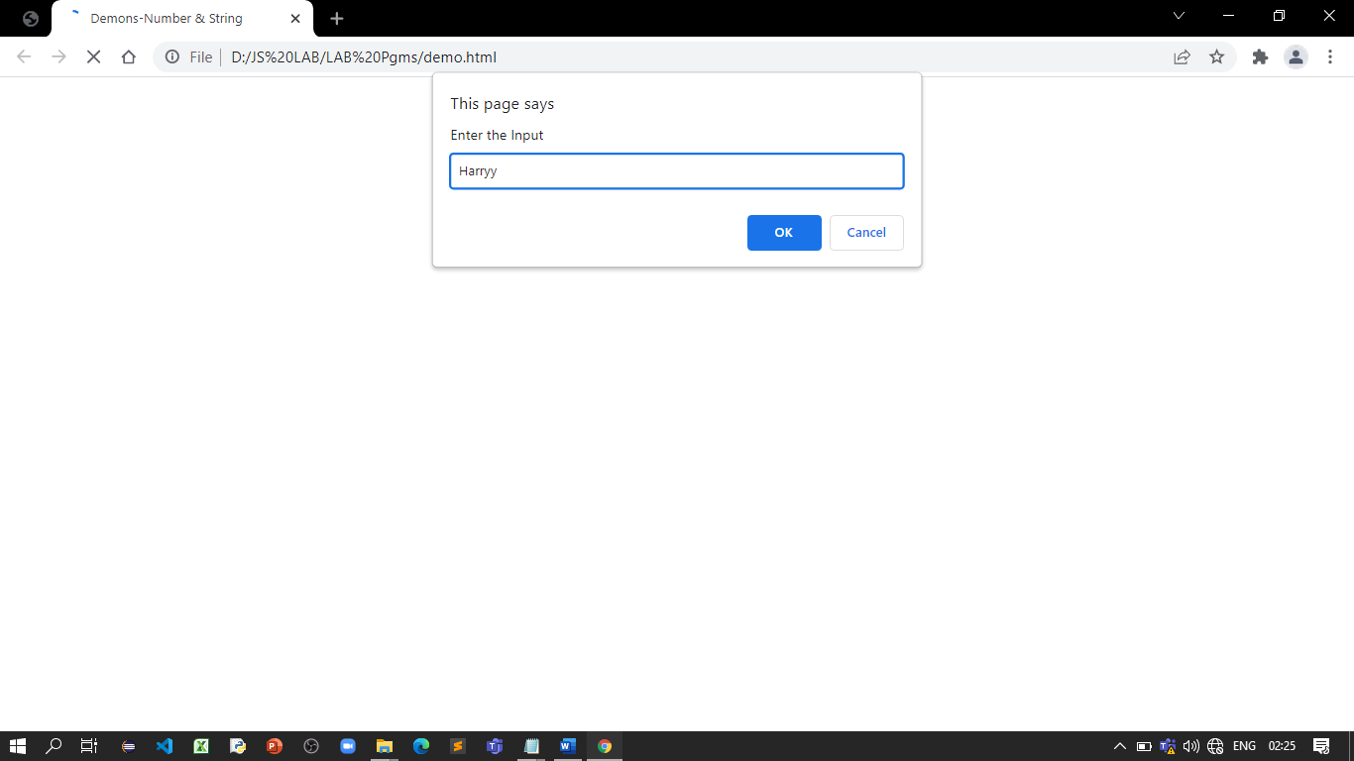

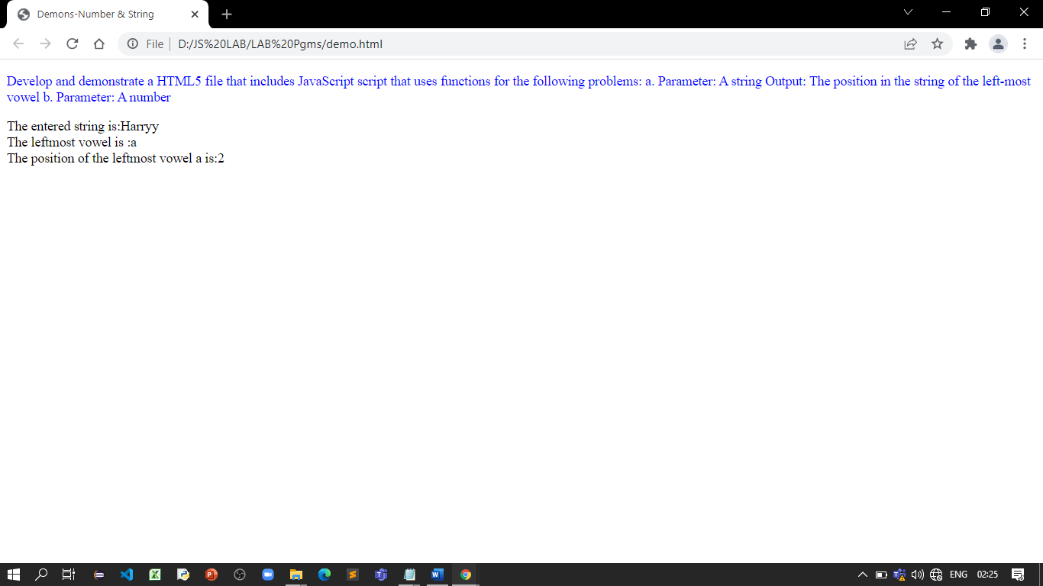

**References:**

* <https://vtucselabs.blogspot.com/2019/08/wt4.html>

# Activity 15

## Aim: Write a JavaScript code that displays text “TEXT-GROWING” with increasing font size in the interval of 100ms in RED COLOR, when the font size reaches 50pt it displays “TEXT-SHRINKING” in BLUE color. Then the font size decreases to 5pt.

**Learning outcome:** Able to understand JavaScript

**Duration:** 3 Hours

**List of Hardware/Software requirements:**

1. Windows/Ubuntu OS
2. Text Editors- Notepad++, VS Code, Sublime Text, etc.
3. Web Browser (Chrome/Firefox)

**Program:**

<!DOCTYPE html>

<html lang="en">

<head> <! -- Document Head Starts -->

<meta charset="UTF-8">

<meta http-equiv="X-UA-Compatible" content="IE=edge">

<meta name="viewport" content="width=device-width, initial-scale=1.0">

<title>Text- Grow & Shrink</title>

<style>

p {

position: absolute;

top: 50%;

left: 50%;

transform: translate(-50%, -50%);

}

</style>

</head> <! -- Document Head Ends -->

<body> <! -- Document Body Starts -->

<h1>Text -Growing & Shrinking</h1>

<p id="demo"></p>

<script> //Javascript Starts

var var1 = setInterval(inTimer, 3000);

var fs = 5;

var ids = document.getElementById("demo");

function inTimer() {

ids.innerHTML = 'JS Program';

ids.setAttribute('style', "font-size: " + fs + "px; color: red"); fs += 5;

if(fs >= 50 ){

clearInterval(var1);

var2 = setInterval(deTimer, 2000);

}

}

function deTimer() {

fs -= 5;

ids.innerHTML = 'JS Program';

ids.setAttribute('style', "font-size: " + fs + "px; color: blue"); if(fs === 5 ){

clearInterval(var2);

}

}

</script> //Javascript Ends

</body> <! -- Document Body Ends -->

</html>

**Output:**

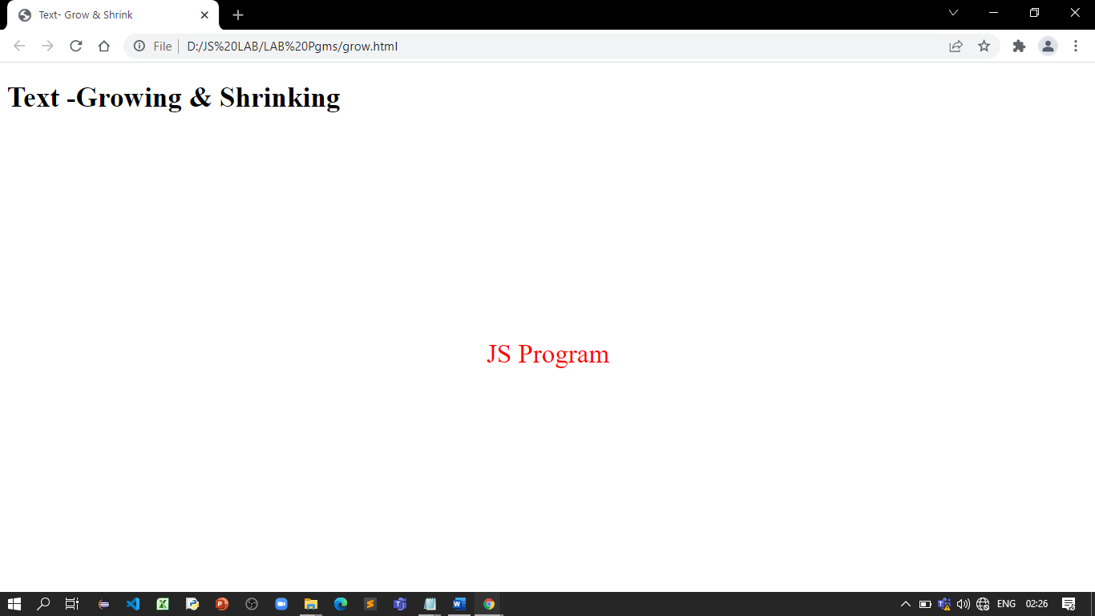

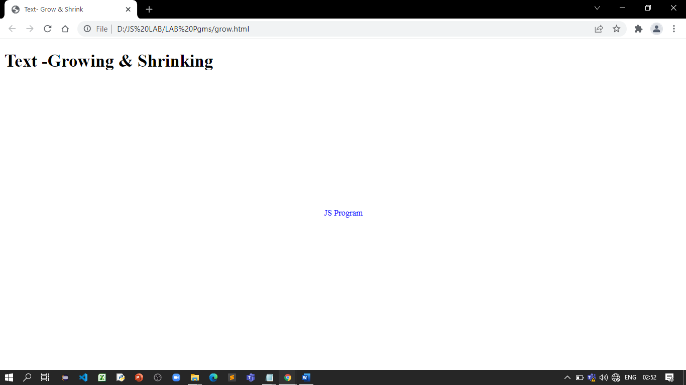

**References:**

* <https://vtucselabs.blogspot.com/2019/08/wt3.html>

# Activity 16

## Aim: Create a Tip Calculator as a single page web application (SPA). Design an interface that allows you to enter the amount of the tip. The percentage you would like to tip, and the number of people to split the tip with. Do not use 3 text input elements! Calculate and dynamically display the tip.

## Learning outcome: Able to understand JavaScript

**Duration:** 3 Hours

**List of Hardware/Software requirements:**

1. Windows/Ubuntu OS
2. Text Editors- Notepad++, VS Code, Sublime Text, etc.
3. Web Browser (Chrome/Firefox)

**Program:**

<!DOCTYPE html>

<html lang="en">

<head> <! -- Document Head Starts -->

<meta charset="UTF-8">

<meta name="viewport" content="width=device-width, initial-scale=1.0">

<meta http-equiv="X-UA-Compatible" content="ie=edge">

<title>Document</title>

<style media="screen">

*,

*:before,

*:after {

margin: 0;

padding: 0;

box-sizing: border-box;

}

html {

font-size: 100%;

}

body {

width: 100%;

height: 100vh;

overflow: hidden;

display: grid;

place-items: center;

background: rgb(12, 141, 195);

font-family: "Lato", sans-serif;

font-weight: 400;

line-height: 1.75;

}

p {

margin-bottom: 1rem;

}

h1{

background: rgb(11, 108, 161);

color: white;

font-size: 27px;

text-align: center;

margin-top: -17px;

margin-left: -17px;

margin-right: -17px;

}

.h3 {

margin: 1.38rem 0;

font-size: 1.424rem;

}

#tip-calculator {

width: 80%;

max-width: 350px;

padding: 1rem;

background: white;

border-radius: 0.3rem;

}

#output {

text-align: center;

box-shadow: 0 0 20px rgba(0,139,253,0.25);

padding: 10px;

color: rgb(9, 73, 171);

}

form {

border-top: 1px solid hsl(149, 31%, 25%);

}

label {

display: block;

}

input[type="number"] {

width: 100%;

max-width: 4em;

background: none;

border: none;

font-size: 20px;

color: rgb(26, 64, 237);

border-bottom: 1px dashed black;

/* Hide spinners and steppers - Firefox */

-moz-appearance: textfield;

}

/* Hide spinners and steppers - Chrome, Safari, Edge, Opera */

input[type="number"]::-webkit-outer-spin-button,

input[type="number"]::-webkit-inner-spin-button {

-webkit-appearance: none;

margin: 0;

}

#people {

max-width: 3em;

}

#percentage {

-webkit-appearance: none;

width: 100%;

margin: 2rem 0;

height: 10px;

background: hsl(193, 94%, 34%);

border-radius: 3px;

}

#percentage::-webkit-slider-thumb {

-webkit-appearance: none;

appearance: none;

width: 30px;

height: 30px;

border-radius: 50%;

border: 2px solid rgb(5, 47, 156);

background: hsl(255, 14%, 66%);

cursor: pointer;

}

#percentage::-moz-range-thumb {

width: 20px;

height: 20px;

background: hsl(149, 31%, 98%);

border-radius: 50%;

cursor: pointer;

}

</style>

</head> <! -- Document Head Ends -->

<body> <! -- Document Body Starts -->

<div id="tip-calculator">

<h1>Tip Calculator</h1>

<form id="form">

<label for="bill" class="h3">

Bill: $

<input type="number" min="0" step="0.01" value="50" name="bill" id="bill" />

</label>

<label for="people" class="h3">

People:

<input type="number" min="1" step="1" value="1" name="people" id="people" />

</label>

<label for="percentage" class="h3">

Tip Percentage:

<span id="percentage-output"></span>

<input type="range" min="0" max="100" step="1" value="20" name="percentage" id="percentage" />

</label>

</form>

<div id="output" class="h3"></div>

</div>

<script type="text/javascript">

// cached elements

const form = document.getElementById("form");

const totalBill = document.getElementById("bill");

const totalPeople = document.getElementById("people");

const tipPercentage = document.getElementById("percentage");

const percentageOutput = document.getElementById("percentage-output");

const output = document.getElementById("output");

// event listeners

form.addEventListener("change", calculateTip);

tipPercentage.oninput = calculateTip;

// event handlers

function calculateTip() {

const dollarsPerPerson = (

(totalBill.value * (tipPercentage.value / 100)) /

totalPeople.value

).toFixed(2);

displayTip(`$${dollarsPerPerson}`);

displayPercentage();

}

// helper functions

function displayTip(totalPerPerson) {

output.innerText =

totalPeople.value > 1

? `Each person should tip ${totalPerPerson}`

: `You should tip ${totalPerPerson}`;

}

function displayPercentage() {

percentageOutput.innerText = `${tipPercentage.value}%`;

}

// on load

calculateTip();

</script> //Javascript Ends

</body> <! -- Document Body Ends -->

</html>

**Output:**

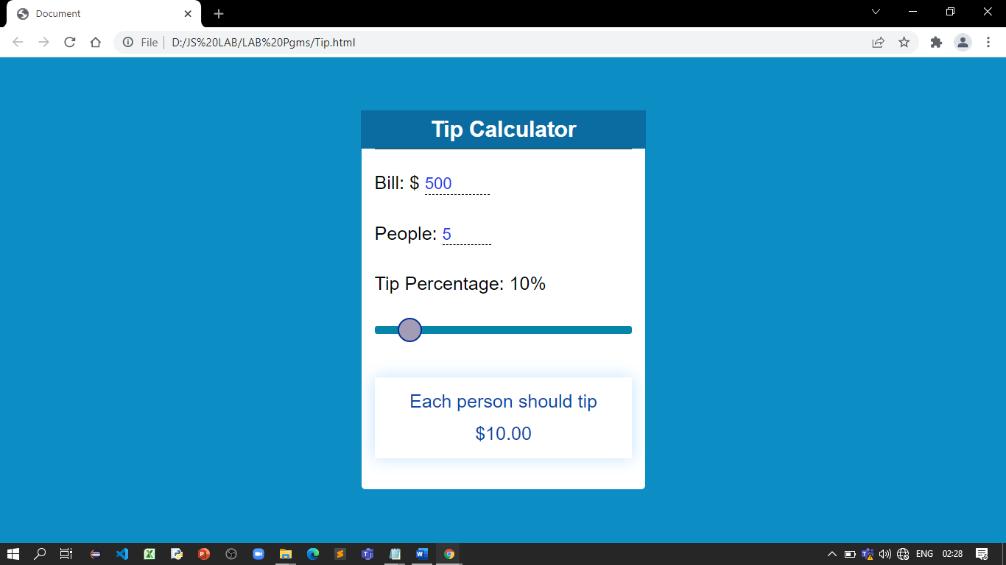

**References:**

* <https://www.freecodecamp.org/news/how-to-build-a-tip-calculator-with-html-css-and-javascript/>

# Activity 17

## Aim: Write a JavaScript function to validate whether a given value is object or not.

## Learning outcome: Able to understand JavaScript

**Duration:** 1 Hour

**List of Hardware/Software requirements:**

1. Windows/Ubuntu OS
2. Text Editors- Notepad++, VS Code, Sublime Text, etc.
3. Web Browser (Chrome/Firefox)

**Program:**

<!DOCTYPE html>

<html lang="en">

<head> <! -- Document Head Starts -->

<meta charset="UTF-8">

<meta http-equiv="X-UA-Compatible" content="IE=edge">

<meta name="viewport" content="width=device-width, initial-scale=1.0">

<title>JS_Object</title>

</head> <! -- Document Head Ends -->

<body> <! -- Document Body Starts -->

<p>JavaScript function to validate whether a given value is object or not.</p>

<script> //Javascript Starts

function is_object(value)

{

var datatype = typeof value;

return datatype === 'function' || datatype === 'object' && !!value;

}

console.log(is_object({name: 'Robert'}));

console.log(is_object('bar'));

console.log(is_object(72));

</script> //Javascript Ends

</body> <! -- Document Body Ends -->

</html>

**Output:**

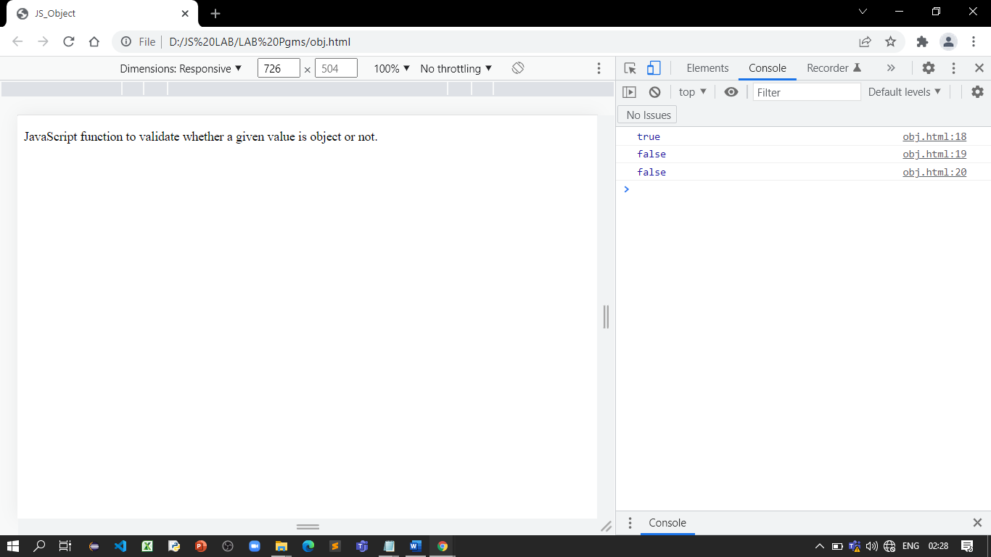

**References:**

* <https://www.w3resource.com/javascript-exercises/validation/javascript-validation-exercise-6.php>

# Activity 18

## Aim: Write a JavaScript function to validate whether a given value type is pure json object or not

## Learning outcome: Able to understand JavaScript

**Duration:** 1 Hour

**List of Hardware/Software requirements:**

1. Windows/Ubuntu OS
2. Text Editors- Notepad++, VS Code, Sublime Text, etc.
3. Web Browser (Chrome/Firefox)

**Program:**

<!DOCTYPE html>

<html lang="en">

<head> <! -- Document Head Starts -->

<meta charset="UTF-8">

<meta http-equiv="X-UA-Compatible" content="IE=edge">

<meta name="viewport" content="width=device-width, initial-scale=1.0">

<title>JS_Json Object</title>

</head> <! -- Document Head Ends -->

<body> <! -- Document Body Starts -->

<p>JavaScript function to validate whether a given value type is pure json object or not</p>

<script> //Javascript Starts

function is_json(value)

{

return toString.call(value) === '[object Object]';

}

console.log(is_json({name: 'Robert'}));

console.log(is_json('bar'));

console.log(is_json(72));

</script> //Javascript Ends

</body> <! -- Document Body Ends -->

</html>

**Output:**

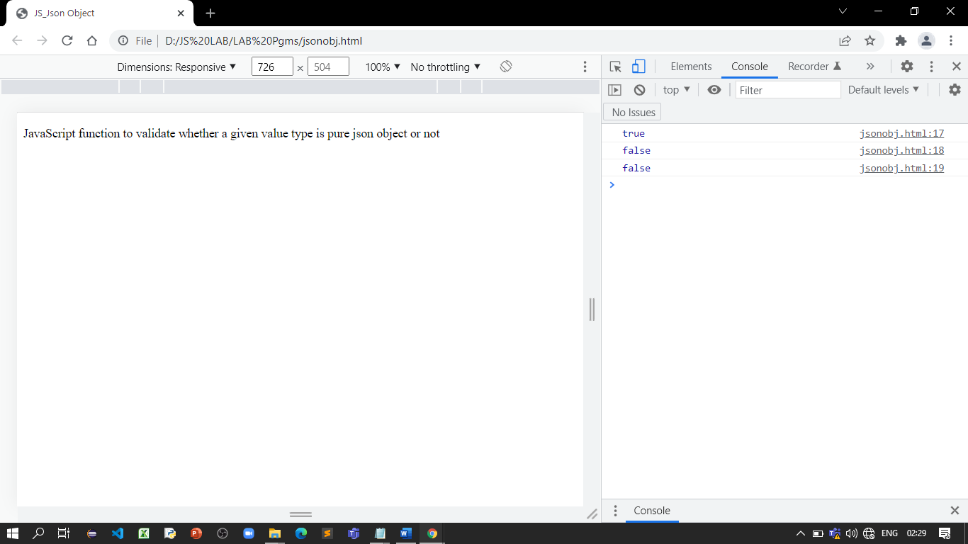

**References:**

* <https://www.w3resource.com/javascript-exercises/validation/javascript-validation-exercise-7.php>

# Activity 19

## Aim: Write a JavaScript program to count number of words in string.

## Note:

## Remove white-space from start and end position.

## Convert 2 or more spaces to 1.

## Exclude newline with a start spacing.

## Learning outcome: Able to understand JavaScript

**Duration:** 3 Hours

**List of Hardware/Software requirements:**

1. Windows/Ubuntu OS
2. Text Editors- Notepad++, VS Code, Sublime Text, etc.
3. Web Browser (Chrome/Firefox)

**Program:**

<!DOCTYPE html>

<html lang="en">

<head> <! -- Document Head Starts -->

<meta charset="UTF-8">

<meta http-equiv="X-UA-Compatible" content="IE=edge">

<meta name="viewport" content="width=device-width, initial-scale=1.0">

<title>No of Words</title>

<style type="text/css">

body {margin-top: 40px;}

</style>

</head> <! -- Document Head Ends -->

<body> <! -- Document Body Starts -->

<p>Count number of words in a string</p>

<textarea id="InputText" cols="30" rows="4">India is our Country</textarea>

</br>

<input type="button" name="Convert" value="No. of Words" onClick="count_words();">

<input id = "noofwords" type="text" value="" size="6">

<script> //Javascript Starts

function count_words()

{

str1= document.getElementById("InputText").value;

//exclude start and end white-space

str1 = str1.replace(/(^\s*)|(\s*$)/gi,"");

//convert 2 or more spaces to 1

str1 = str1.replace(/[ ]{2,}/gi," ");

// exclude newline with a start spacing

str1 = str1.replace(/\n /,"\n");

document.getElementById("noofwords").value = str1.split(' ').length;

}

</script> //Javascript Ends

</body> <! -- Document Body Ends -->

</html>

**Output:**

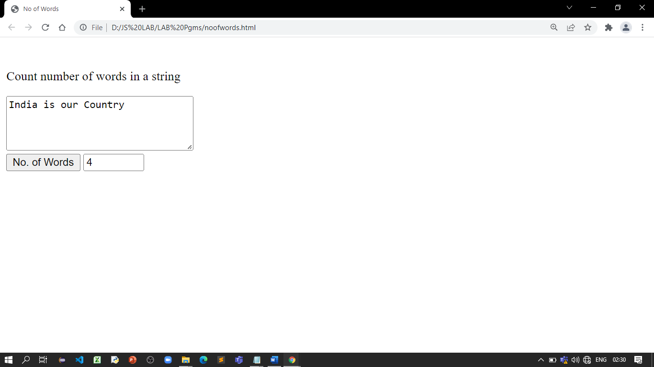

**References:**

* <https://www.w3resource.com/javascript-exercises/javascript-regexp-exercise-6.php>

# Activity 20

## Aim: Write a JavaScript function to check a given value contains alpha, dash and underscore.

## Learning outcome: Able to understand JavaScript

**Duration:** 1 Hour

**List of Hardware/Software requirements:**

1. Windows/Ubuntu OS
2. Text Editors- Notepad++, VS Code, Sublime Text, etc.
3. Web Browser (Chrome/Firefox)

**Program:**

<!DOCTYPE html>

<html lang="en">

<head> <! -- Document Head Starts -->

<meta charset="UTF-8">

<meta http-equiv="X-UA-Compatible" content="IE=edge">

<meta name="viewport" content="width=device-width, initial-scale=1.0">

<title>Special Character</title>

</head> <! -- Document Head Ends -->

<body> <! -- Document Body Starts -->

<p>JavaScript function to check a given value contains alpha, dash and underscore</p>

<script> //Javascript Starts

function is_alphaDash(str)

{

regexp = /^[a-z0-9_\-]+$/i;

if (regexp.test(str))

{

return true;

}

else

{

return false;

}

}

console.log(is_alphaDash('12-133'));

console.log(is_alphaDash('100_23'));

</script> //Javascript Ends

</body> <! -- Document Body Ends -->

</html>

**Output:**

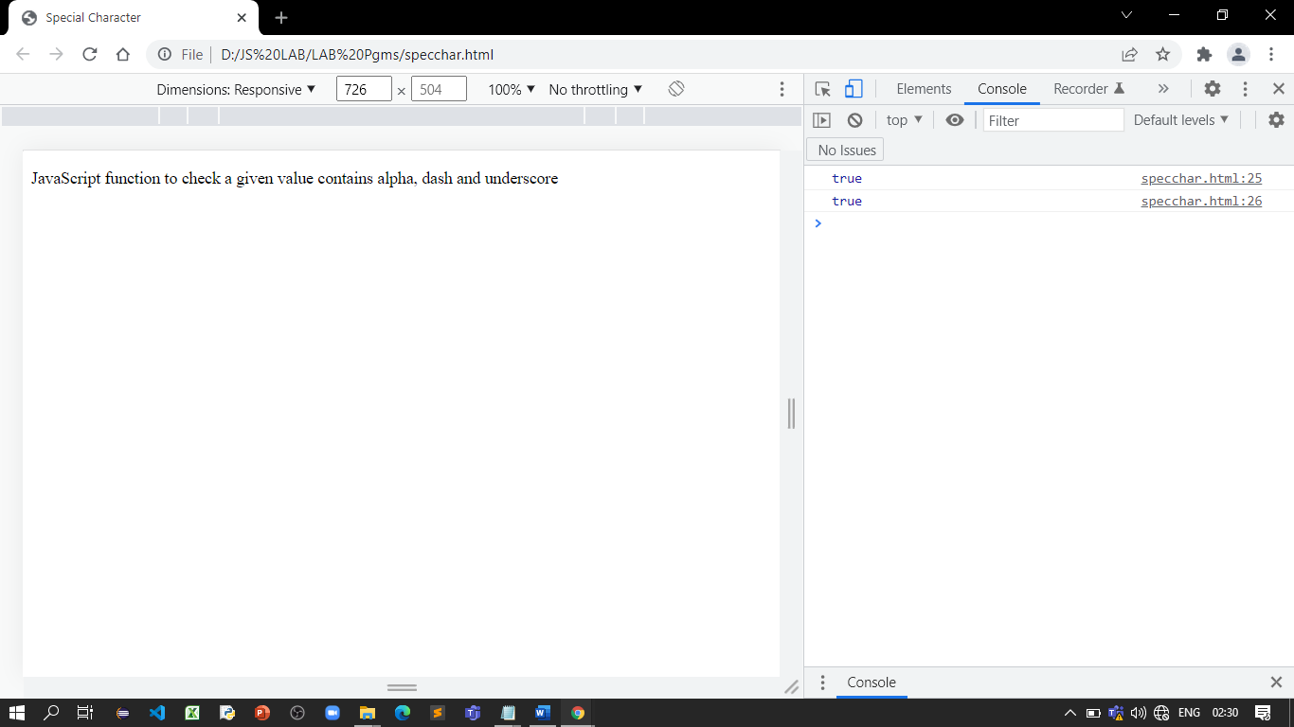

**References:**

* <https://www.w3resource.com/javascript-exercises/javascript-regexp-exercise-20.php>

# Activity 21

## Aim: Write a JavaScript function to check whether a given value represents a domain or not.

## Write a JavaScript function to check whether a given value is html or not.

## Learning outcome: Able to understand JavaScript

**Duration:** 1 Hour

**List of Hardware/Software requirements:**

1. Windows/Ubuntu OS
2. Text Editors- Notepad++, VS Code, Sublime Text, etc.
3. Web Browser (Chrome/Firefox)

**Program:**

<!DOCTYPE html>

<html lang="en">

<head> <! -- Document Head Starts -->

<meta charset="UTF-8">

<meta http-equiv="X-UA-Compatible" content="IE=edge">

<meta name="viewport" content="width=device-width, initial-scale=1.0">

<title>Check Domain</title>

</head> <! -- Document Head Ends -->

<body> <! -- Document Body Starts -->

<p>JavaScript function to check whether a given value represents a domain or not</p>

<script> //Javascript Starts

function is_domain(str)

{

regexp = /^[a-z0-9]+([\-\.]{1}[a-z0-9]+)*\.[a-z]{2,6}$/i;

if (regexp.test(str))

{

return true;

}

else

{

return false;

}

}

console.log(is_domain('www.example.com'));

console.log(is_domain('www.npm.co.uk'));

console.log(is_domain('http://www.example.com'));

console.log(is_domain('https://www.example.com'));

</script> //Javascript Ends

</body> <! -- Document Body Ends -->

</html>

**Output:**

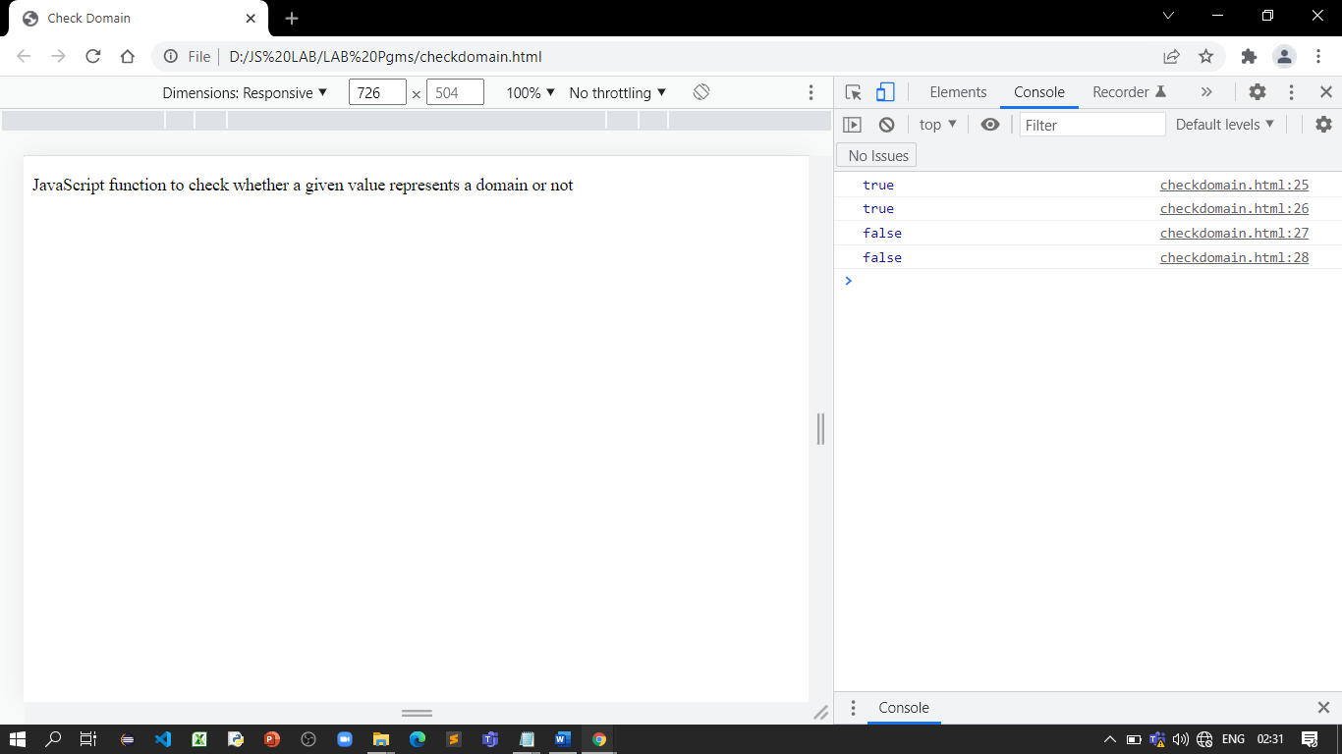

**Program:**

<!DOCTYPE html>

<html lang="en">

<head> <! -- Document Head Starts -->

<meta charset="UTF-8">

<meta http-equiv="X-UA-Compatible" content="IE=edge">

<meta name="viewport" content="width=device-width, initial-scale=1.0">

<title>Check HTML</title>

</head> <! -- Document Head Ends -->

<body> <! -- Document Body Starts -->

<p>JavaScript function to check whether a given value is html or not</p>

<script> //Javascript Starts

function is_html(str)

{

regexp = /<([a-z]+) *[^/]*?>/;

if (regexp.test(str))

{

return true;

}

else

{

return false;

}

}

console.log(is_html('<h1>'));

console.log(is_html(''));

console.log(is_html('.selector'));

</script> //Javascript Ends

</body> <! -- Document Body Ends -->

</html>

**Output:**

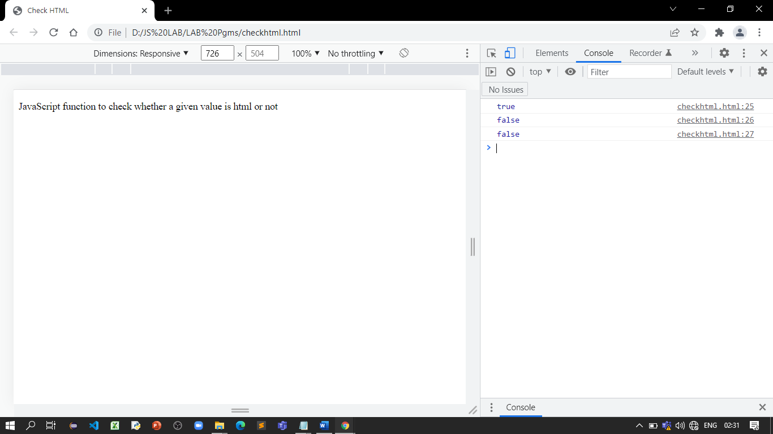

**References:**

* <https://www.w3resource.com/javascript-exercises/javascript-regexp-exercise-18.php>
* <https://www.w3resource.com/javascript-exercises/javascript-regexp-exercise-19.php>